Feynman Diagram Practice
Modern Physics

- Draw all 4 second order (2 vertices) Feynman diagrams to represent Compton scattering $e+γ→e+γ$.
- Is the following diagram a valid second order diagram for electron-positron pair production $2γ→e+e^{+}$? Justify your answer. If it is not valid, suggest an alternative diagram.

- Consider the Feynman toy theory from the notes. Calculate the amplitude for the fundamental vertex shown below. Evaluate it to completion.

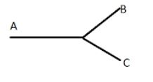

- Again, with the Feynman toy theory, consider the scattering process $A+A→B+B$. There are two second order Feynman diagrams for this process (hint: there’s a twisted one!) Draw them and calculate the amplitude to completion for both. The total amplitude is just the sum of each diagram’s amplitude!

